**WEB DEVLOPMENT PROJECT-I**

**This project is basically a collection of few web pages which are made with the help of two programming languages HTML and CSS. The theme of the this project is a website where you can download Korean web series. Here are some screen shots of the website.**

**SCREENSHOTS**



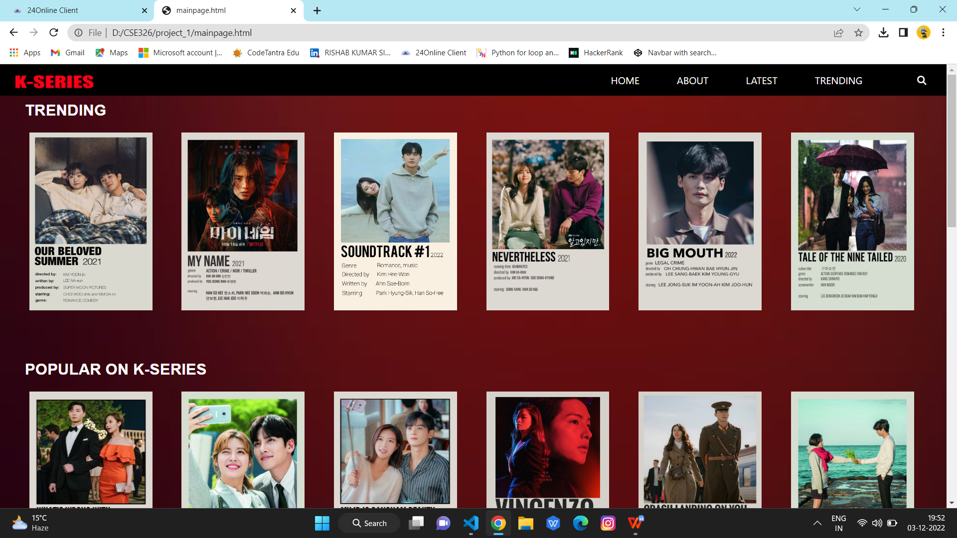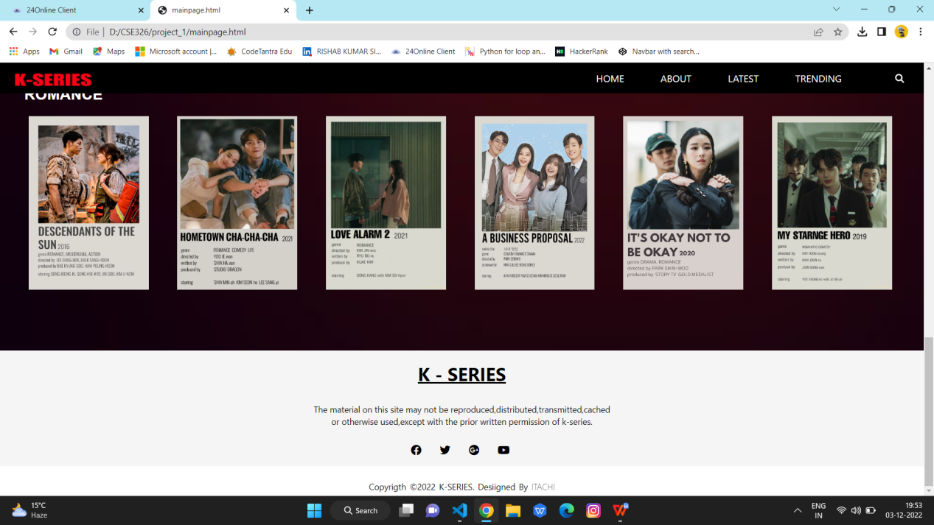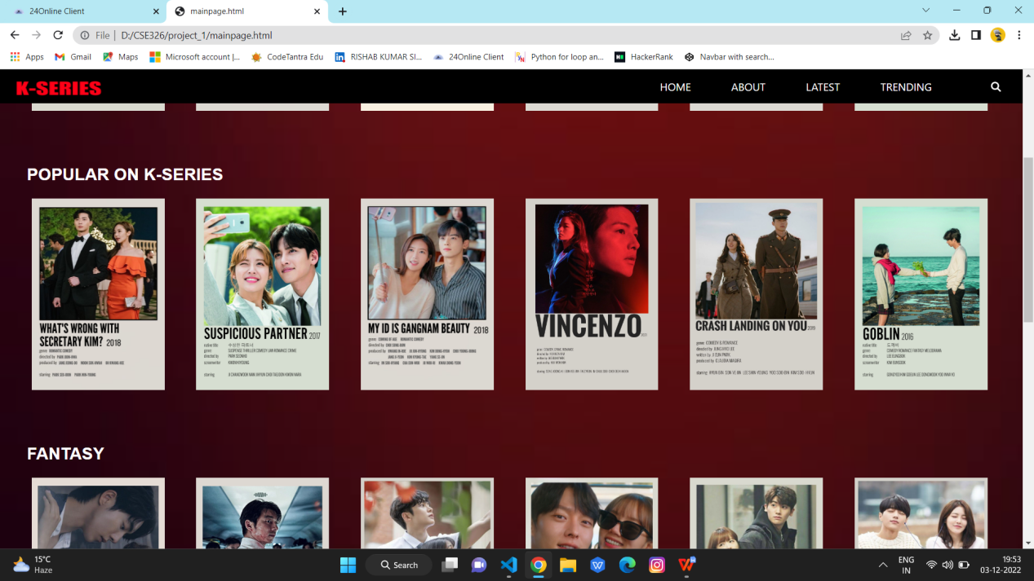

**NAME : RISHAB KUMAR SINGH**

**REG. NO. : 12213405**

**SECTION : K22MB**

**UNDER THE GUIDENCE OF : RADHIKA NAMBIAR**